Strawberry - Rhubarb  Jam  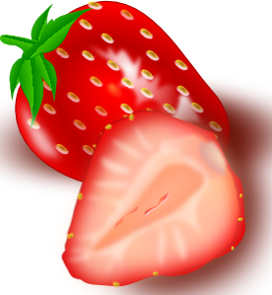  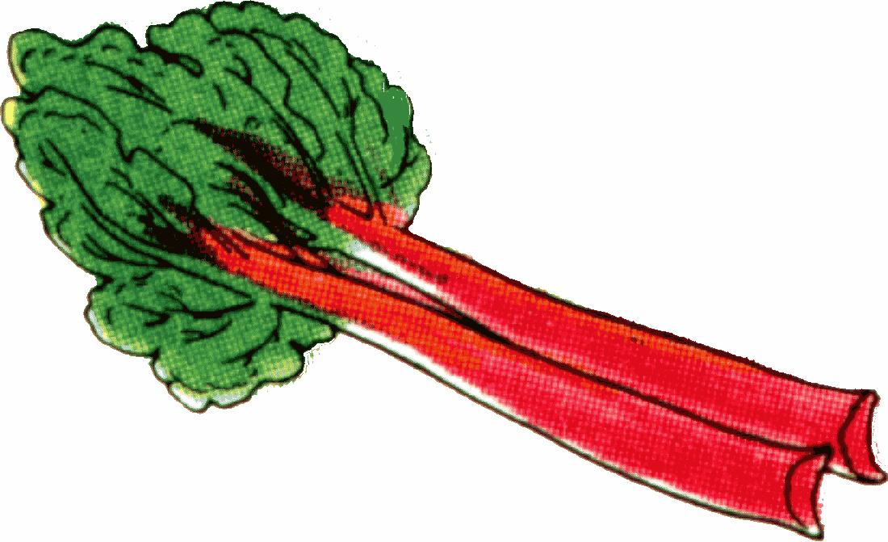 |  |  |  | Strawberry - Rhubarb  Jam
Strawberry - Rhubarb
Jam
Strawberry - Rhubarb  Jam |  |  |  | Strawberry - Rhubarb  Jam
Strawberry - Rhubarb
Jam

